

Batches handover
The codebase, running it, keeping it healthy, and growing it
━━━━━━

Ladles of Love · Batches warehouse system
For the developers and IT partners who look after Batches next
October 2026

Contents
Contents 2
1. Batches in one page 3
2. How the system fits together 4
3. The codebase 5
3.1 Where things are 5
3.2 The rules the code follows 5
3.3 Cross-cutting pieces 6
3.4 Follow one feature: receiving a delivery 6
3.5 Tests 6
4. Running and hosting it 8
4.1 On your machine 8
4.2 Hosting on Render 8
5. The database 9
5.1 What it holds 9
5.2 Changing the database 9
5.3 Backups 9
6. Looking after it 10
6.1 Routine tasks 10
6.2 Scheduled jobs 10
6.3 Secrets and keys 10
6.4 When something goes wrong 10
7. Bringing in another warehouse 12
7.1 Adding a site to one app (option B) 12
7.2 Setting the site up 12
8. Security 13
9. Growing it 14
9.1 Today's limits and what to do 14
9.2 Open decisions and loose ends 14
9.3 Where to read more 14

1. Batches in one page
Batches is the Ladles of Love warehouse system. It runs purchase orders and receiving, stock, decanting, picking slips and packing, dispatch, donations and Section 18A certificates, benevolent requests, Feed the Soil, volunteer events and reporting. Warehouse staff use it on phones; managers and admins use it in a browser.
Screens | React 19 and Vite, Tailwind, installable as an app (PWA). Works offline on the floor.
Server | Node.js 22 and Express 5, one process
Database | PostgreSQL on Supabase
Hosting | Render, one web service that serves both the screens and the API
Code | One Git repository: client/, server/, docs/
Tests | About 2,100 client and 4,300 server tests, run with npm test

Your first week
1. Get access to the GitHub repository, the Render service and the Supabase project.
2. Run it on your machine (section 4.1) and read CODEBASE.md in the repository.
3. Follow one feature from screen to database (section 3.4).
4. Check Settings > Connections in the live app: it shows what is switched on and working.
5. Read the open decisions in section 9.

2. How the system fits together
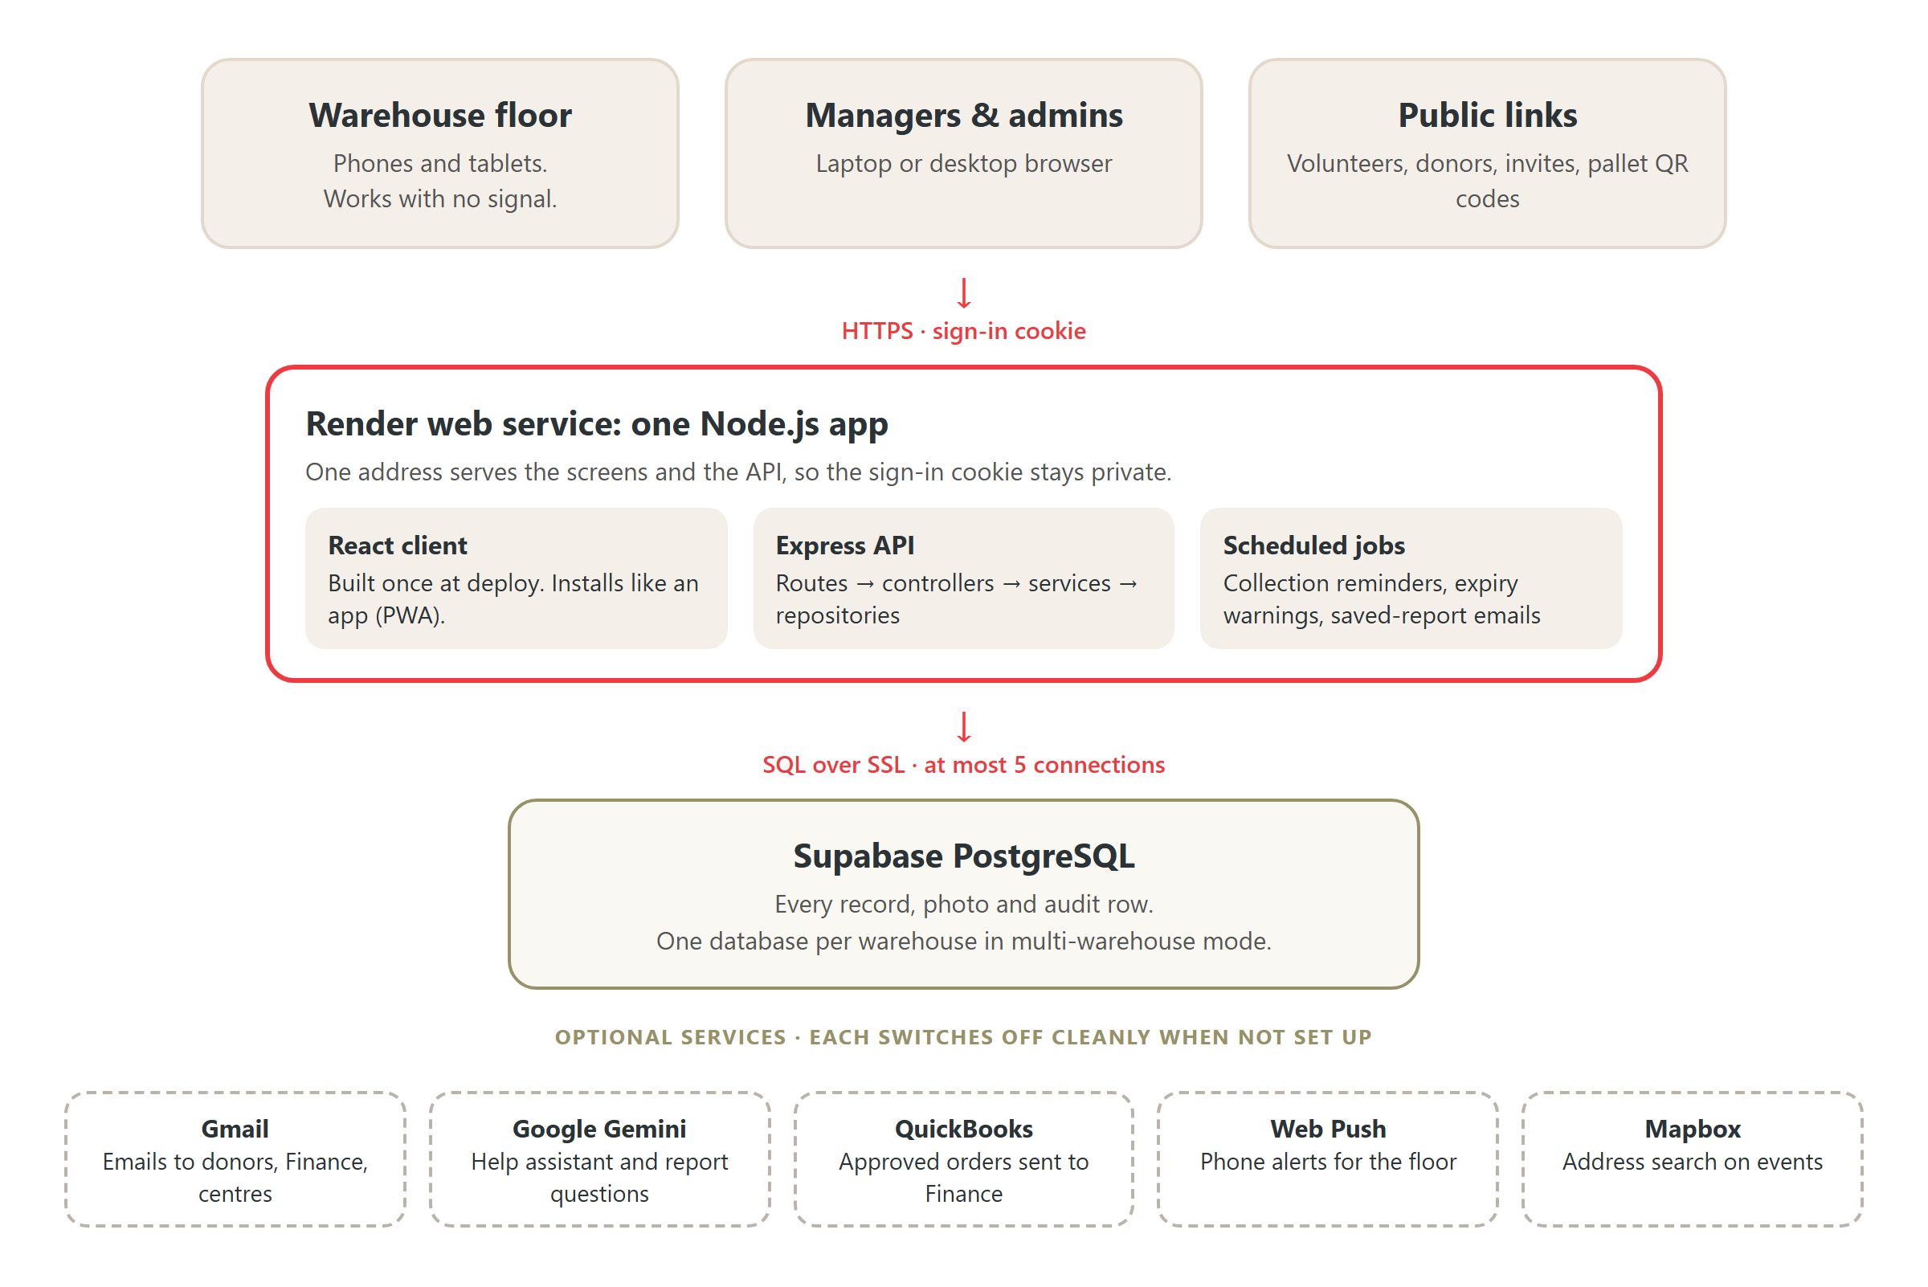
Everything runs as one web service in front of one database
- One address for everything. The sign-in cookie is set to stay on the site that issued it. Splitting the screens and the API across two addresses would make every request after sign-in fail, so they are deliberately served together.
- Optional services switch off cleanly. With no Gemini key the help assistant and report questions are hidden; with no push keys the bell still works; with no QuickBooks keys Finance is emailed instead.
- Who sees what is set once in client/src/routes/routeTable.js (the menu and page access) and enforced again on every server route with requireRole(...).

3. The codebase

3.1 Where things are
Folder | What is in it
client/src/pages/ | One file per screen. Kept thin: a page lays out feature components.
client/src/features/<area>/ | Everything for one area (receiving, packing, reporting and so on), in one flat folder
client/src/components/ | ui/: shared building blocks (buttons, tables, list toolbar). layout/: menus and the shells for each role.
client/src/services/ | The only code that talks to the server. One file per area, plus the offline outbox.
client/src/routes/ | Every screen's address, who may open it and which menu it is in
client/src/translations/ | Afrikaans and isiXhosa for the floor
server/src/routes/ | Each address and the roles allowed to call it
server/src/controllers/ | Read the request, call a service, send the answer
server/src/services/ | The business rules. Refuses bad requests with a clear message.
server/src/repositories/ | All the SQL
server/src/features/ | Calculations and catalogues the layers share: the report catalogue, units, recipes, settings
server/src/jobs/ | The three scheduled jobs
server/database/ | schema.sql (every table) and numbered migrations
server/scripts/ | Command-line tools: migrations, multi-warehouse admin, data loaders

3.2 The rules the code follows
- Four server layers, each calling only the one below: route → controller → service → repository. SQL appears only in repositories. A service may open a transaction and hand its connection to the repositories it calls, so several writes succeed or fail together.
- Same name in every layer. To follow purchase orders, open purchaseOrder.routes.js, .controller.js, .service.js and .repository.js.
- One list, one place. Roles, purchase-order statuses, donation categories and storage areas each live once in server/src/constants/. Report metrics live once in features/reporting/reportCatalog.js.
- Screens never call the server directly; they go through client/src/services/.
- Every change is recorded. Writes add a row to audit_log in the same transaction, never with a password or token in it.
CODEBASE.md in the repository lists the three deliberate exceptions to the layering rule and where new work belongs.

3.3 Cross-cutting pieces
Concern | Where it lives
Sign-in and roles | server/src/middleware/auth.middleware.js, client/src/context/AuthContext.jsx
Working with no signal | client/src/services/outbox.js keeps work on the phone; server/src/middleware/idempotency.middleware.js makes sure a resent request is only done once
Stock | stock.repository.js adjustStock: the balance and the ledger line change together. Stock comes off at dispatch, not packing.
Notifications | features/communications/notices.js, written inside the same transaction as the change they announce
Emails | communications.service.js through the connected Gmail account; every send is logged in Message history
Settings an admin can change | server/src/features/settings/settingsDefinitions.js (defaults and limits)
Several warehouses | server/src/config/dbRouter.js and warehouseContext.js pick the database for each request

3.4 Follow one feature: receiving a delivery
Step | File
The screen | client/src/features/receiving/ReceivingFlow.jsx (and ReceivingParts.jsx)
The call | client/src/services/receivingAPI.js recordDelivery
The address and role check | server/src/routes/delivery.routes.js
The request | server/src/controllers/delivery.controller.js
The rules | server/src/services/delivery.service.js
The SQL | server/src/repositories/delivery.repository.js createDelivery
The stock ledger | server/src/repositories/stock.repository.js adjustStock
The tests | server/__tests__/ and client/src/tests/

3.5 Tests
- cd client && npm run lint && npm test, and cd server && npm test. Both must pass before merging.
- server/__tests__/fixtures/routeRoles.baseline.json records who may call every address. Changing a route's roles fails a test until you update that file on purpose.
- Server tests use a mocked database. npm run test:integration runs some against a real one; never point it at the live database.
- GitHub Actions lints and builds the client and runs the server tests on every push. It does not run the client tests yet; run them yourself.

4. Running and hosting it

4.1 On your machine
You need Node.js 22 and a Postgres database to point at (a copy, never the live one).
Step | Command
Server settings | cd server, copy env.example to .env, fill in at least DATABASE_URL and JWT_SECRET. Set DB_POOL_MAX=3.
Start the server | npm install then npm run dev (http://localhost:5000)
Client settings | cd client, copy env.local.example to .env.local
Start the client | npm install then npm run dev (http://localhost:5173)

server/env.example lists every setting with what it does and its default; client/env.local.example does the same for the client.

4.2 Hosting on Render
- What runs: one Render web service built from render.yaml. The build compiles the client; Express then serves it and the API from one address.
- Which branch: staging/(DEVELOPMENT-TESTING) today. Point Render at main once that is the branch you release from.
- Health check: /api/health. Render restarts the service if it stops answering.
- Secrets are pasted into the Render dashboard, never committed: DATABASE_URL, GEMINI_API_KEY, the Gmail, QuickBooks and push keys. JWT_SECRET is generated by Render.
- Free plan: the service sleeps after 15 idle minutes and takes about 50 seconds to wake. Move to a paid plan before relying on it every day (section 8).
Deploying a change
Merge to the deployed branch. Render builds the new version, then switches over to it.
If the change has a database migration, run it before the deploy (section 5.2), so the new code never meets an old database.

5. The database

5.1 What it holds
- Supabase PostgreSQL. server/database/schema.sql describes every table; read it, do not run it.
- Photos (flagged items, deliveries) are stored in the photos table, shrunk to about 1,280 pixels. There is room for a few thousand. To move them to file storage, change only photo.repository.js.
- Connections: the Supabase session pooler allows 15 in total. Each server keeps at most 5 (DB_POOL_MAX). A live server, a deploy starting beside it and two developers fill it: developers should use 3.

5.2 Changing the database
Command (in `server/`) | What it does
npm run migrate -- status | What is applied and what is waiting, for every database
npm run migrate -- up | Applies waiting migrations to every database. Checks all are reachable first, runs each file in its own transaction, and stops at the first failure.
npm run migrate -- init <code> | Builds a new, empty warehouse database

- Add the next numbered file to server/database/migrations/ (for example 048_add_something.sql), and make the same change in schema.sql.
- Never change one warehouse's database by hand. Every site must run the same schema.

5.3 Backups
Check this first
Confirm the Supabase plan's backups and how far back you can restore. The free plan has no point-in-time recovery.
Take a manual backup (pg_dump, or Supabase's download) before every migration and every bulk data load.
Practise a restore into a spare project once, so you know it works before you need it.

6. Looking after it

6.1 Routine tasks
How often | Task
Every week | Look at Settings > Connections (email, AI, push, QuickBooks) and Message history for failed emails
Every month | Read Render's logs for errors. Check Supabase database size and connection use. Ask an admin to deactivate people who have left.
Every quarter | Update dependencies (npm outdated in client/ and server/), run all tests, deploy. Test a backup restore.
Every year | Check the Gemini model names in render.yaml are still offered, and that the Gmail and QuickBooks connections have not expired

6.2 Scheduled jobs
Job | When | Switch
Collection reminders to centres | Daily at the hour set in Settings | ECD_REMINDER_SCHEDULER=false turns it off on that server
Expiry warnings, idle Feed the Soil kits, QuickBooks retries | Checked hourly, acts once a day | Always on. Safe to run twice: it skips anything already sent.
Saved-report emails | On each report's schedule | SAVED_REPORTS_SCHEDULER=false

6.3 Secrets and keys
Secret | If you change it
JWT_SECRET | Everyone is signed out and signs in again. Change it at once if it may have leaked.
GMAIL_TOKEN_ENCRYPTION_KEY | The Gmail account must be connected again in Settings
VAPID_PUBLIC_KEY / VAPID_PRIVATE_KEY | Every phone must turn alerts on again. Do not rotate casually.
DATABASE_URL | Update it in Render; the service restarts
GEMINI_API_KEY | No side effects. Free-tier limits are per model; backup models are listed in GEMINI_FALLBACK_MODELS.

6.4 When something goes wrong
Symptom | Likely cause and fix
First page takes ~50 s | Free Render plan waking up. Upgrade the plan.
"max clients reached" at start-up | Database connections full. Lower DB_POOL_MAX on developer machines, or stop a stray server.
Help assistant or report questions missing | GEMINI_API_KEY not set, or the model retired. Check Settings > Connections.
Emails not arriving | Gmail disconnected or EMAIL_ENABLED=false. Check Message history and reconnect Gmail.
Signed in, then every request fails | Screens and API served from different addresses. Keep them on one (section 2).
A floor worker's saves are stuck | They are queued on the phone. They send when the signal returns; the bar at the top lists them.

7. Bringing in another warehouse
A second site can join in one of two ways. Both keep each site's data in its own database.
 | A. Its own copy | B. One app, several warehouses
How | A second Render service and Supabase project | The same service; add the site to WAREHOUSE_DB_URLS
Best for | A separate organisation, or a trial | Ladles of Love sites that share staff
Staff at two sites | Two accounts | One sign-in, with a warehouse switcher
Updates | Deploy and migrate each copy | One deploy; migrate -- up updates every site
Cost | Hosting and database per site | One service; one database per site

7.1 Adding a site to one app (option B)
1 | Create a new Supabase project for the site and copy its connection string.
2 | Add it to WAREHOUSE_DB_URLS (a JSON list keyed by a short code, for example "gauteng") and its display name to WAREHOUSE_NAMES. Do this in your local .env for the next two steps too.
3 | npm run migrate -- init gauteng builds the empty database with every table.
4 | npm run warehouse-admin -- create-admin gauteng --username ... --first ... --last ... makes its first admin and prints a one-time password to hand over.
5 | Put the same WAREHOUSE_DB_URLS in Render and deploy. Staff at more than one site: warehouse-admin -- grant.
6 | Guests at that site sign in with ?w=gauteng on the sign-in link, or choose the site on the sign-in page.

7.2 Setting the site up
- Admin, in the app: products, suppliers, beneficiaries and their cohorts, recipes, users; Settings for cohort days, unit weights, expiry warnings, reminder times, Section 18A certificate details; connect a Gmail account.
- Per deployment (option A only): VITE_WAREHOUSE_NAME and VITE_WAREHOUSE_ADDRESS for the printed-note letterhead, EMAIL_LOGO_URL, and APP_BASE_URL.
- Fixed in code today: receiving offers two storage places (dry store and cold room), and the "near expiry" lists use 14 and 30 days. A site that needs different values needs a small code change (section 9).

8. Security
Protection | How
Passwords | Hashed with bcrypt. The hash is never sent to a screen or written to a log or audit row.
Sign-in session | A signed token in an httpOnly, secure, same-site cookie that page scripts cannot read. Lasts 8 hours (12 for a volunteer).
Who may do what | Every server route checks the role. A test holds every route to a recorded list.
Accounts stay current | Each visit re-reads the account, so deactivating someone or changing their role takes effect at once.
Too many attempts | Sign-in, password reset, invites, account changes and public links are rate-limited (for example 10 sign-ins per 15 minutes).
Changing your own details | Email and password changes need the current password
Links in emails | Invites, password resets and Section 18A forms use random tokens stored only as a hash. Resets work once, for one hour.
Browser protections | Helmet security headers and a content security policy. CORS limited to the app's own address.
Connected accounts | Gmail and QuickBooks tokens are encrypted in the database (AES-256-GCM)
Records | audit_log records who changed what. Nothing is hard-deleted that a record points at: people and products are deactivated or archived.
Data between sites | Each warehouse has its own database. Requests are checked against the warehouses a person has access to.

Keep it secure
Keep secrets in Render and in local .env files only. .env is ignored by Git; keep it that way.
Give the Supabase and Render dashboards to as few people as possible, each with their own login.
Run npm audit with each dependency update.
The /api/health address and the public links are the only things reachable without signing in.

9. Growing it

9.1 Today's limits and what to do
Limit | Grows to | What to do
Free Render plan sleeps | Always on | Move to a paid Render plan. No code change.
15 database connections | More users and servers | Use Supabase's transaction pooler or a larger plan, then raise DB_POOL_MAX
One server | Two or more | Works as is: sessions live in the cookie, and repeated requests are caught in the database. Turn the reminder and saved-report jobs off on all but one server.
Photos in the database | Tens of thousands | Move them to Supabase Storage or S3; only photo.repository.js changes
Report speed | Years of data | Reports are cached briefly. Add indexes for slow reports, or a read replica for reporting.
More sites | Many warehouses | Multi-warehouse mode (section 7). Each site's database grows on its own.

9.2 Open decisions and loose ends
- Receiving offers 2 of the 5 storage areas, and "near expiry" uses fixed 14 and 30 days rather than the Settings values. Decide whether these should follow Settings.
- The Afrikaans and isiXhosa translations are drafts. Ask a fluent speaker to check client/src/translations/ before relying on them.
- CI does not run the client tests. Adding the step needs GitHub permission to edit workflows.
- The operational_goals table is left over from a removed feature and can be dropped.
- The deployed branch is staging/(DEVELOPMENT-TESTING). Agree a release branch and point Render at it.

9.3 Where to read more
Document | For
README.md | Setting up, scripts, things to know
CODEBASE.md | Every folder, where new work goes, the layering rule
server/env.example, client/env.local.example | Every setting
render.yaml | Hosting, with notes on each setting
docs/Batches - How to use the system.docx | Training staff, managers and admins

